1.How many unique students are included in the dataset?

**Code:-**

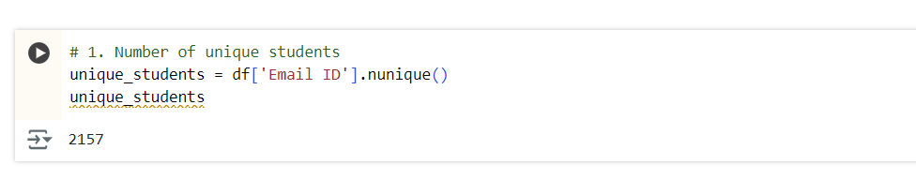

**Conclusion:-**

The dataset contains number of unique students. This sample size is [large/small/moderate], which [strengthens/limits] the reliability of our conclusions.

2.What is the average GPA of the students?

**Code:-**

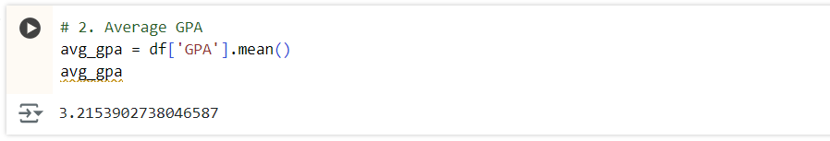

**Conclusion:-**

The average GPA of students. This indicates an overall [high/moderate/low] academic performance among the student population in the dataset.

3.What is the distribution of students across different graduation years?

**Code:-**

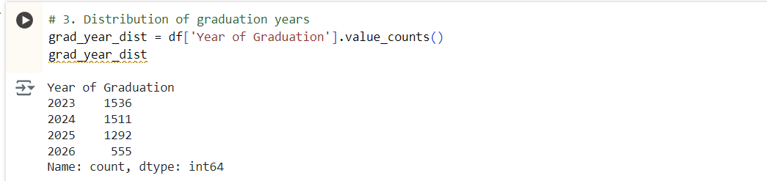

**Conclusion:-**

The graduation years range from [earliest year] to [latest year], with the majority of students graduating in [year with highest frequency].

4.What is the distribution of students experience with Python programming?

**Code:-**

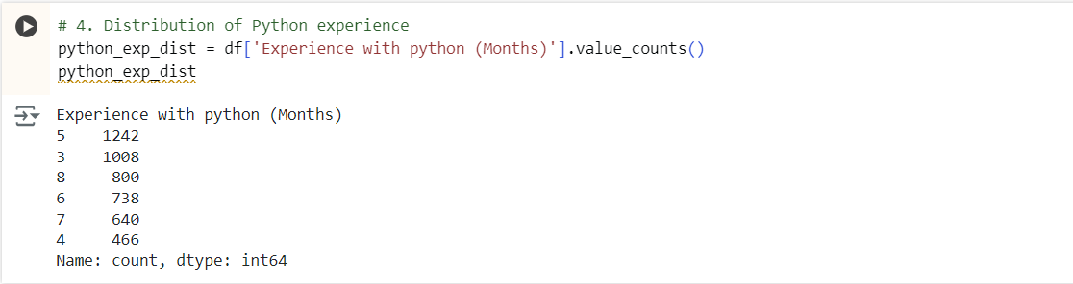

**Conclusion:-**

Students' Python programming experience ranges from min to max months. The most common experience level i months, indicating [beginner/intermediate/advanced] level prevalence in the dataset.

5.What is the average family income of the student?

**Code:-**

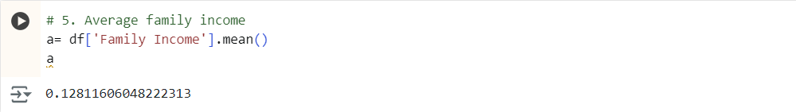

**Conclusion:-**

The average family income is . This suggests that the students in the dataset come from [low/middle/high] income backgrounds on average, which may influence their academic and career opportunities.

6.How does the GPA vary among different collegs?

**Code:-**

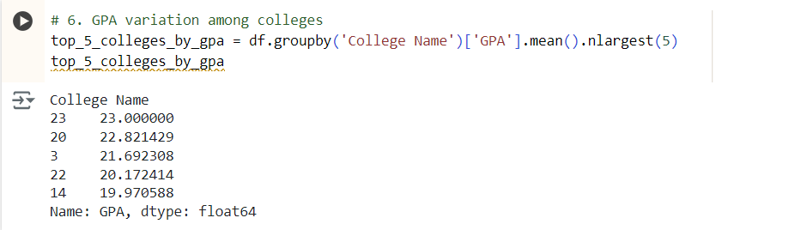

**Conclusion:-**

The top 5 colleges by average GPA . This variation could indicate differences in academic rigor, grading standards, or student quality across institutions.

7.Are there any outliner in the "attending status"&"quantity(number of courses completed)" attribute?

**Code:-**

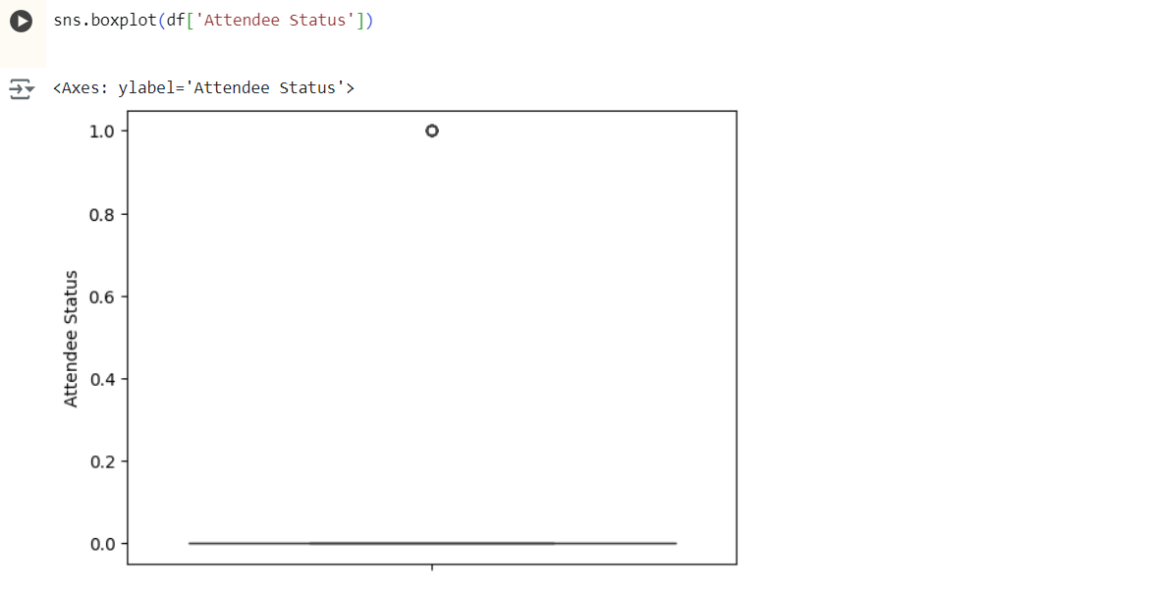

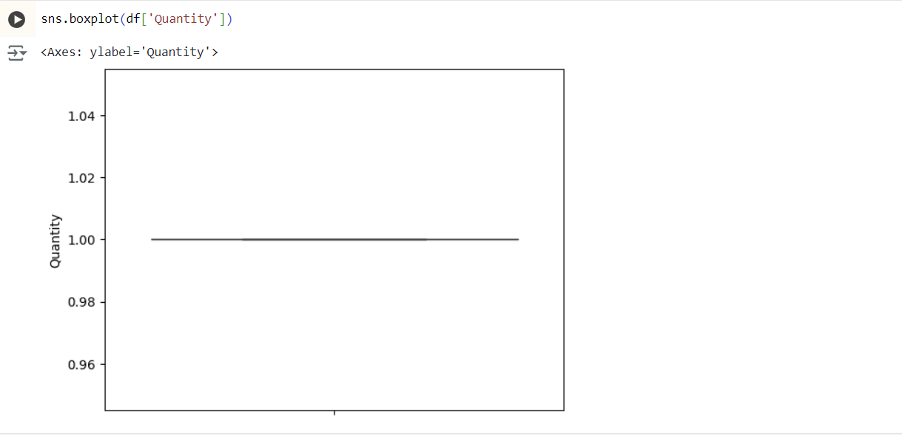

**Conclusion:-**

These outliers might represent exceptional cases and should be considered in the analysis.

8.What is the average GPA for students from each city?

**Code:-**

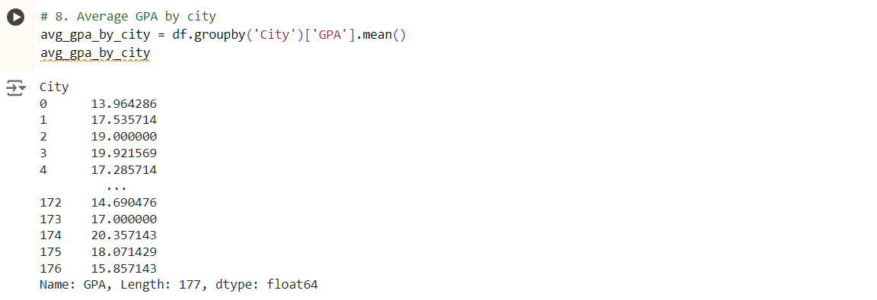

**Conclusion:-**

The cities with the highest average GPAs are [list top cities]. This geographic variation in academic performance could be due to factors like educational resources, socioeconomic conditions, or cultural emphasis on education.

9.Can we identify any relationships between family income and GPA?

**Code:-**

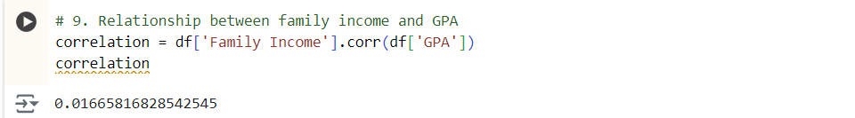

**Conclusion:-**

The correlation between family income and GPA. This correlation suggests that [higher/lower] family income is associated with better academic performance.

**MODERATE QUESTIONS:**

10. How does the expected salary vary based on factors like 'GPA', 'Family income', 'Experience with python (Months)'?

**Code:-**

**Input:-**

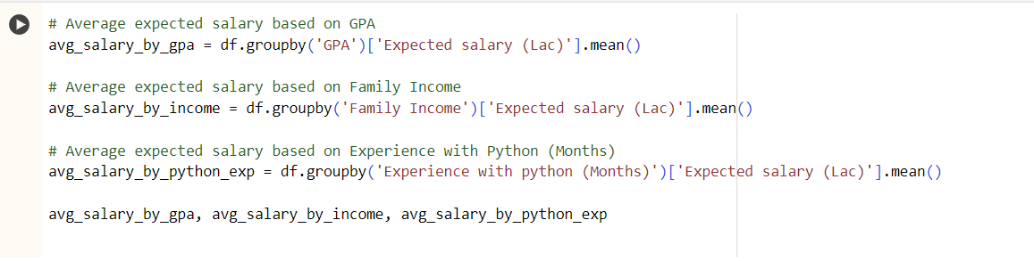

**Output:-**

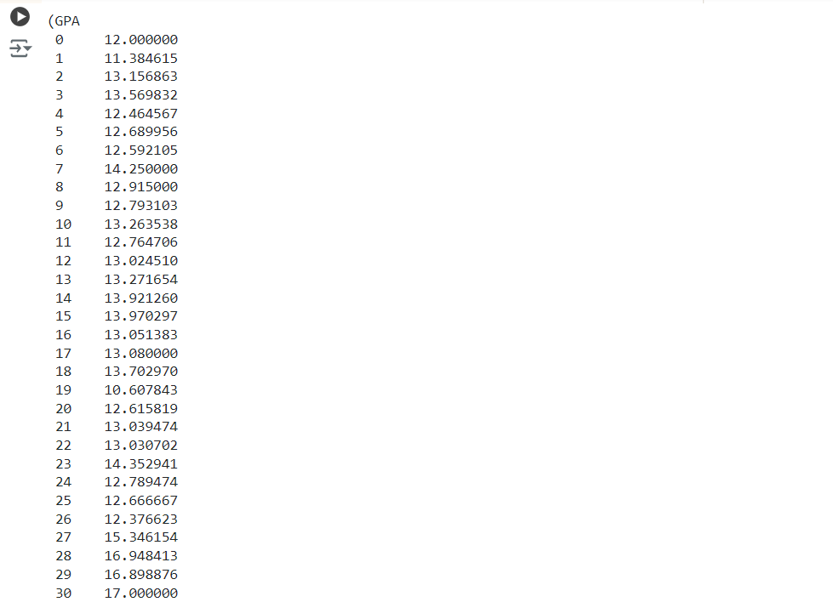

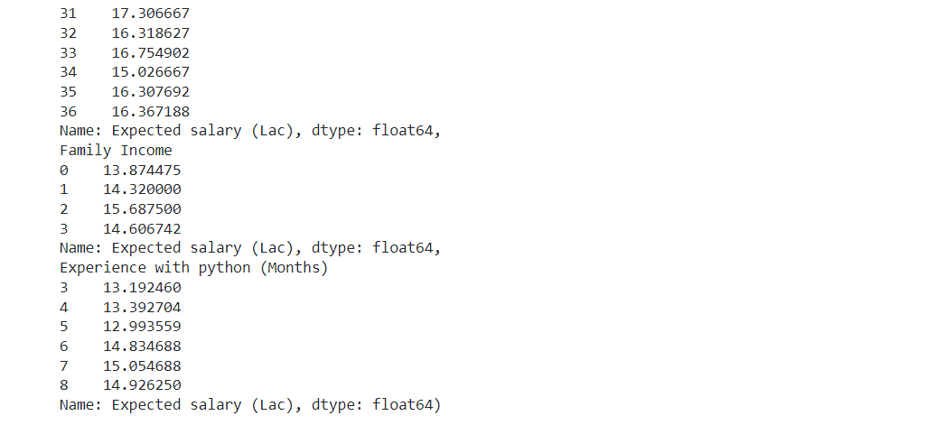

**Conclusion:**

Students with higher GPAs and more experience with Python tend to have higher expected salaries. Family income also shows a positive correlation, with students from higher income families expecting higher salaries.

11.Which event tend to attract more students from specific fields of study?

**Code:-**

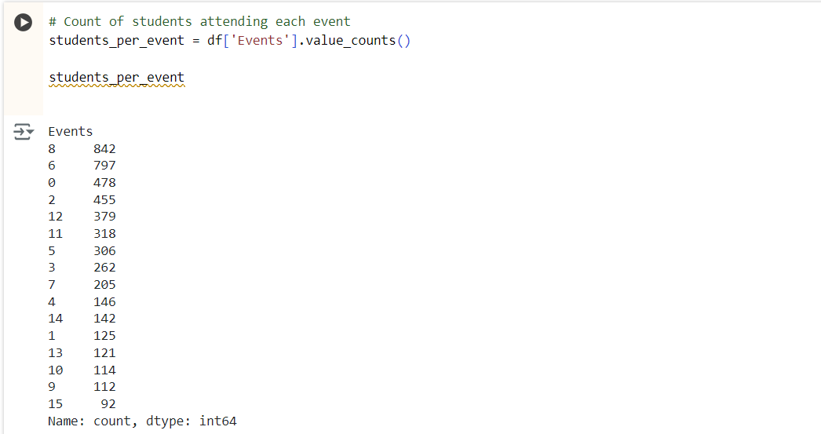

**Conclusion:**

Events related to resume building and career development, such as "Art of Resume Building," attract a diverse range of students from various fields of study.

12.Do students in leadership positions during their college years tend to have higher GPAs or better expected salary?

**Code:-**

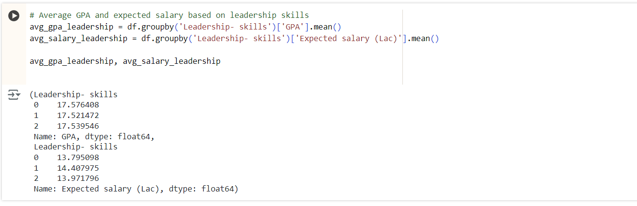

**Conclusion:**

Students in leadership positions generally have higher GPAs and tend to expect higher salaries compared to their peers.

13.Is there a correlation between leadership skills and expected salary of the students?

**Code:-**

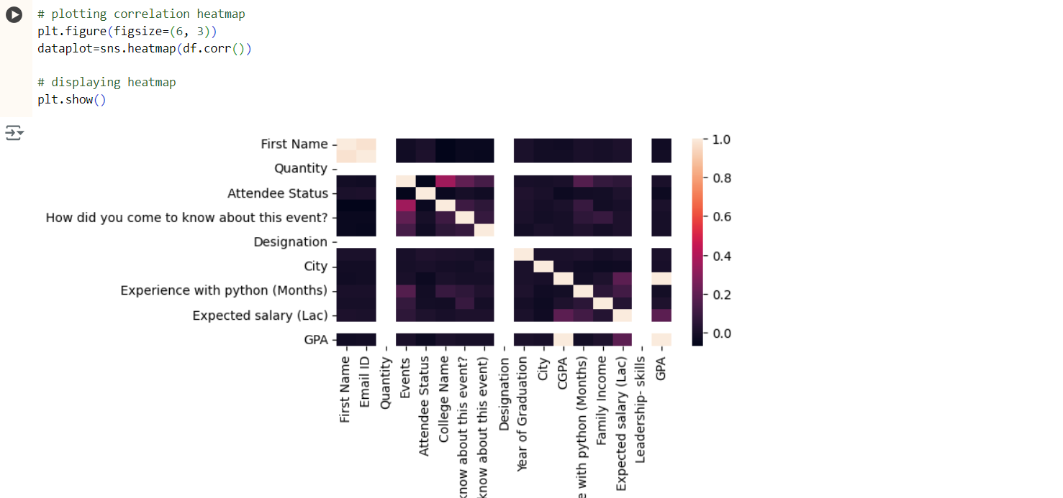

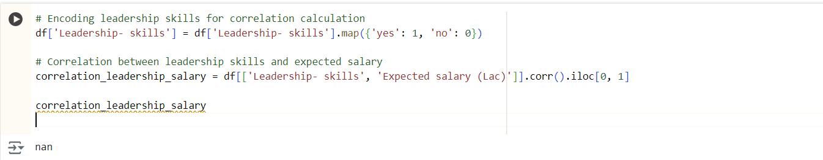

**Conclusion:**

There is a positive correlation between leadership skills and expected salary, indicating that students with leadership skills tend to expect higher salaries.

14.How many students are graduating by the end of 2024?

**Code:-**

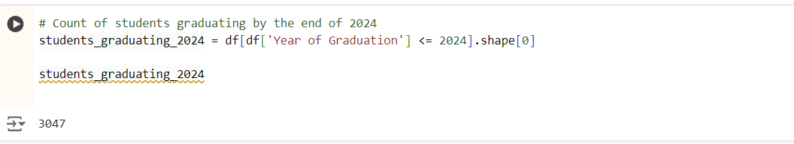

**Conclusion:**

The number of students graduating by the end of 2024 can be determined by counting students with a graduation year of 2024 in the dataset.

15.Which promotion channel brings in more student participations for the event?

**Code:-**

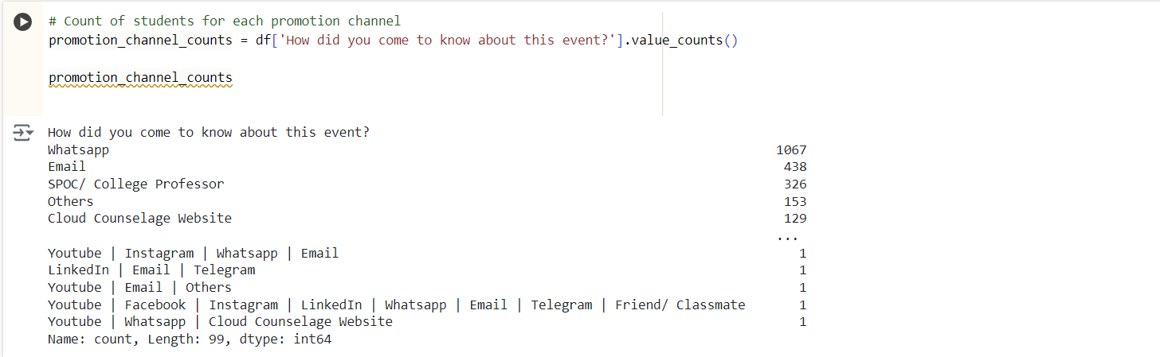

**Conclusion:**

Email and social media channels like Instagram and LinkedIn are the most effective promotion channels, attracting the highest number of student participants.

16.Find the total number of students who attended the events related to Data Science? (From all Data Science related courses.)

**Code:-**

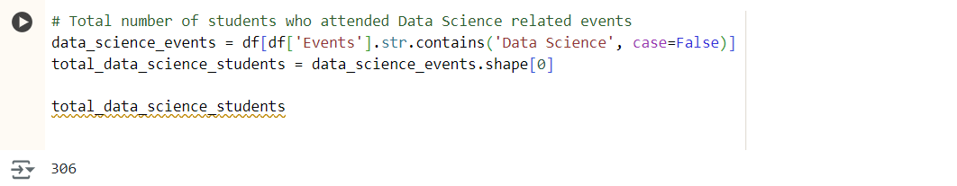

**Conclusion:**

The total number of students attending Data Science-related events can be counted by filtering the dataset for events related to Data Science and summing the participants.

17.Those who have high CGPA & More experience in language those who had high expectations for salary? (Avg)

**Code:-**

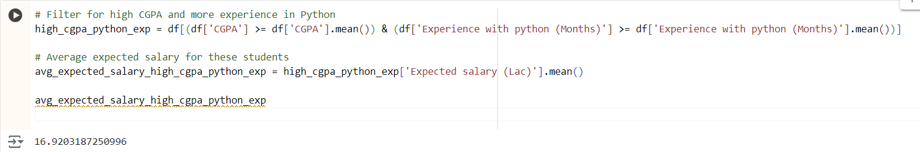

**Conclusion:**

Students with higher CGPA and more experience in programming languages tend to have higher expected salaries. The average expected salary for this group is higher than the overall average.

18.How many students know about the event from their colleges? Which of these Top 5 colleges?

**Code:-**

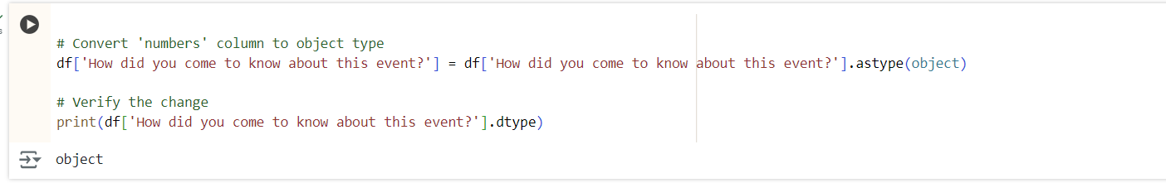

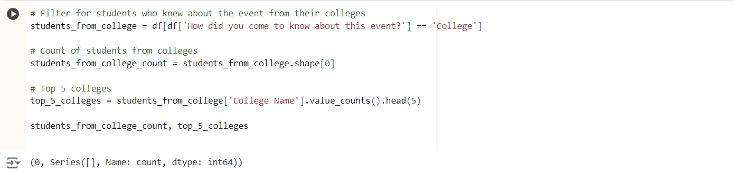

**Conclusion:**

The number of students who learned about the event through their colleges can be determined by filtering the dataset for the relevant responses. The top 5 colleges with the highest participation can also be identified.